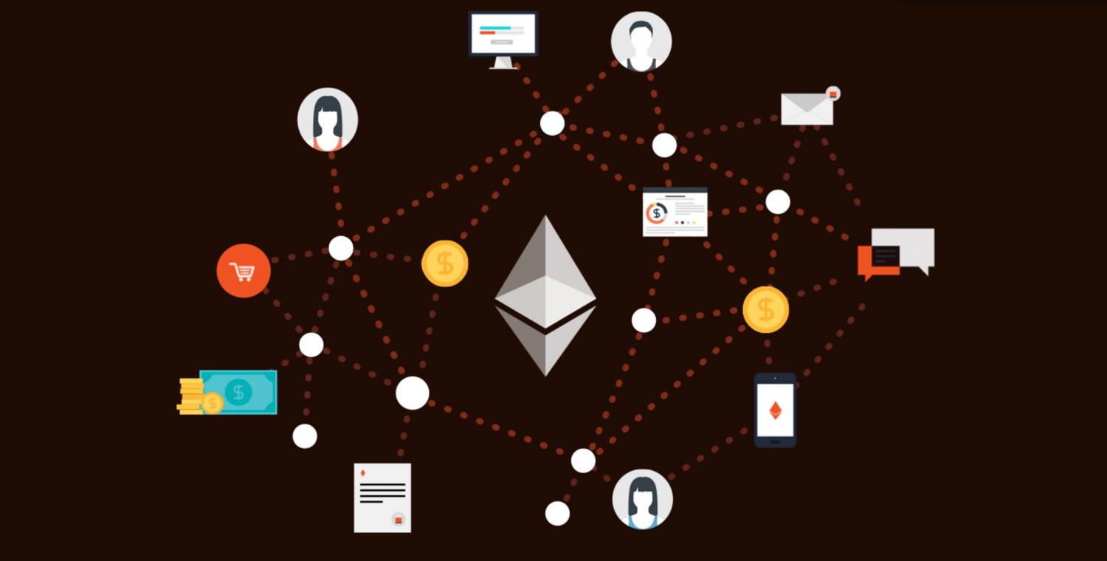Before you can understand ethereum, it helps to first understand the internet.

Today, our personal data, passwords and financial information are all largely stored on other people's computers – in clouds and servers owned by companies like Amazon, Facebook or Google. Even this BlogChain article is stored on a server controlled by a company that charges to hold this data should it be called upon.

This setup has a number of conveniences, as these companies deploy teams of specialists to help store and secure this data, and remove the costs that come with hosting and uptime.

But with this convenience, there is also vulnerability. As we've learned, a hacker or a government can gain unwelcome access to your files without your knowledge, by influencing or attacking a third-party service – meaning they can steal, leak or change important information.

Brian Behlendorf, creator of the Apache Web Server, has gone so far as to label this centralized design the "original sin" of the Internet. Some like Behlendorf argue the Internet was always meant to be decentralized, and a [splintered movement](https://www.wired.com/2016/06/inventors-internet-trying-build-truly-permanent-web/) has sprung up around using new tools, including blockchain technology, to help achieve this goal.

Ethereum is one of the newest technologies to join this movement.

While bitcoin aims to disrupt PayPal and online banking, ethereum has the goal of using a blockchain to replace internet third parties — those that store data, transfer mortgages and keep track of complex financial instruments.

**The 'World Computer'**

In short, ethereum wants to be a 'World Computer' that would decentralize – and some would argue, democratize – the existing client-server model.

With ethereum, servers and clouds are replaced by thousands of so-called "nodes" run by volunteers from across the globe (thus forming a "world computer").

The vision is that ethereum would enable this same functionality to people anywhere around the world, enabling them to compete to offer services on top of this infrastructure.

Scrolling through a typical app store, for example, you’ll see a variety of colorful squares representing everything from banking to fitness to messaging apps. These apps rely on the company (or another third-party service) to store your credit card information, purchasing history and other personal data – somewhere, generally in servers controlled by third-parties.

Your choice of apps is of course also governed by third parties, as Apple and Google maintain and curate (or in some cases, censor) the specific apps you’re able to download.

Take the example of an online document service like Evernote or Google Docs.

Ethereum, if all goes according to plan, would return control of the data in these types of services to its owner and the creative rights to its author.

The idea is that one entity will no longer have control over your notes and that no one could suddenly ban the app itself, temporarily taking all of your notebooks offline. Only the user can make changes, not any other entity.

In theory, it combines the control that people had over their information in the past with the easy-to-access information that we’re used to in the digital age. Each time you save edits, or add or delete notes, every node on the network makes the change.

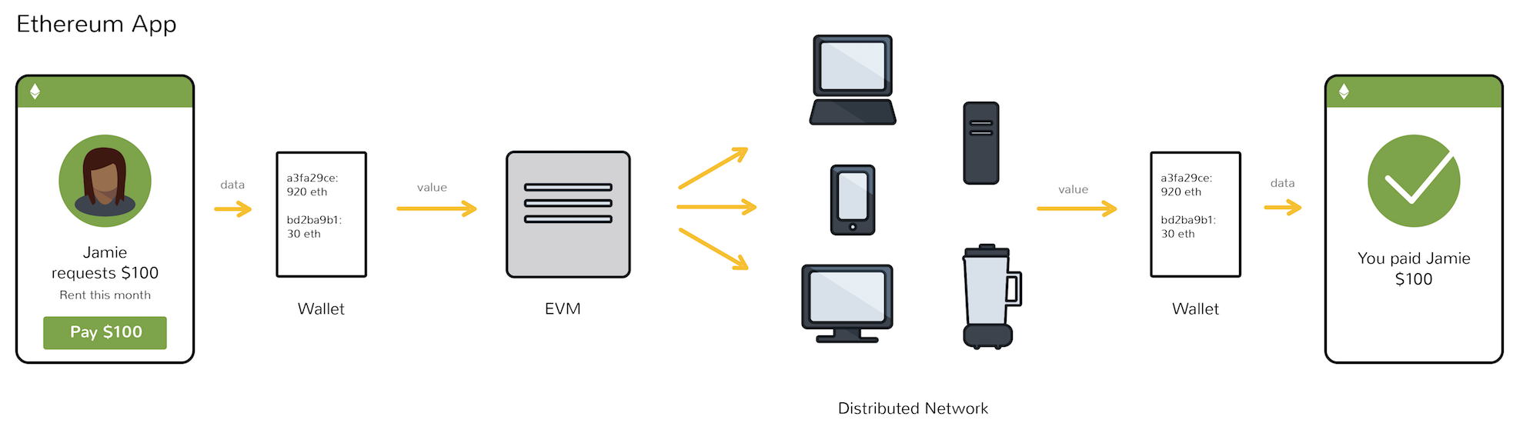

It's worth noting that the idea has been met with skepticism.

Although the apps appear to be possible, it’s unclear which blockchain applications will actually prove useful, secure, or scalable, and if they will ever be as convenient to use as the apps we use today